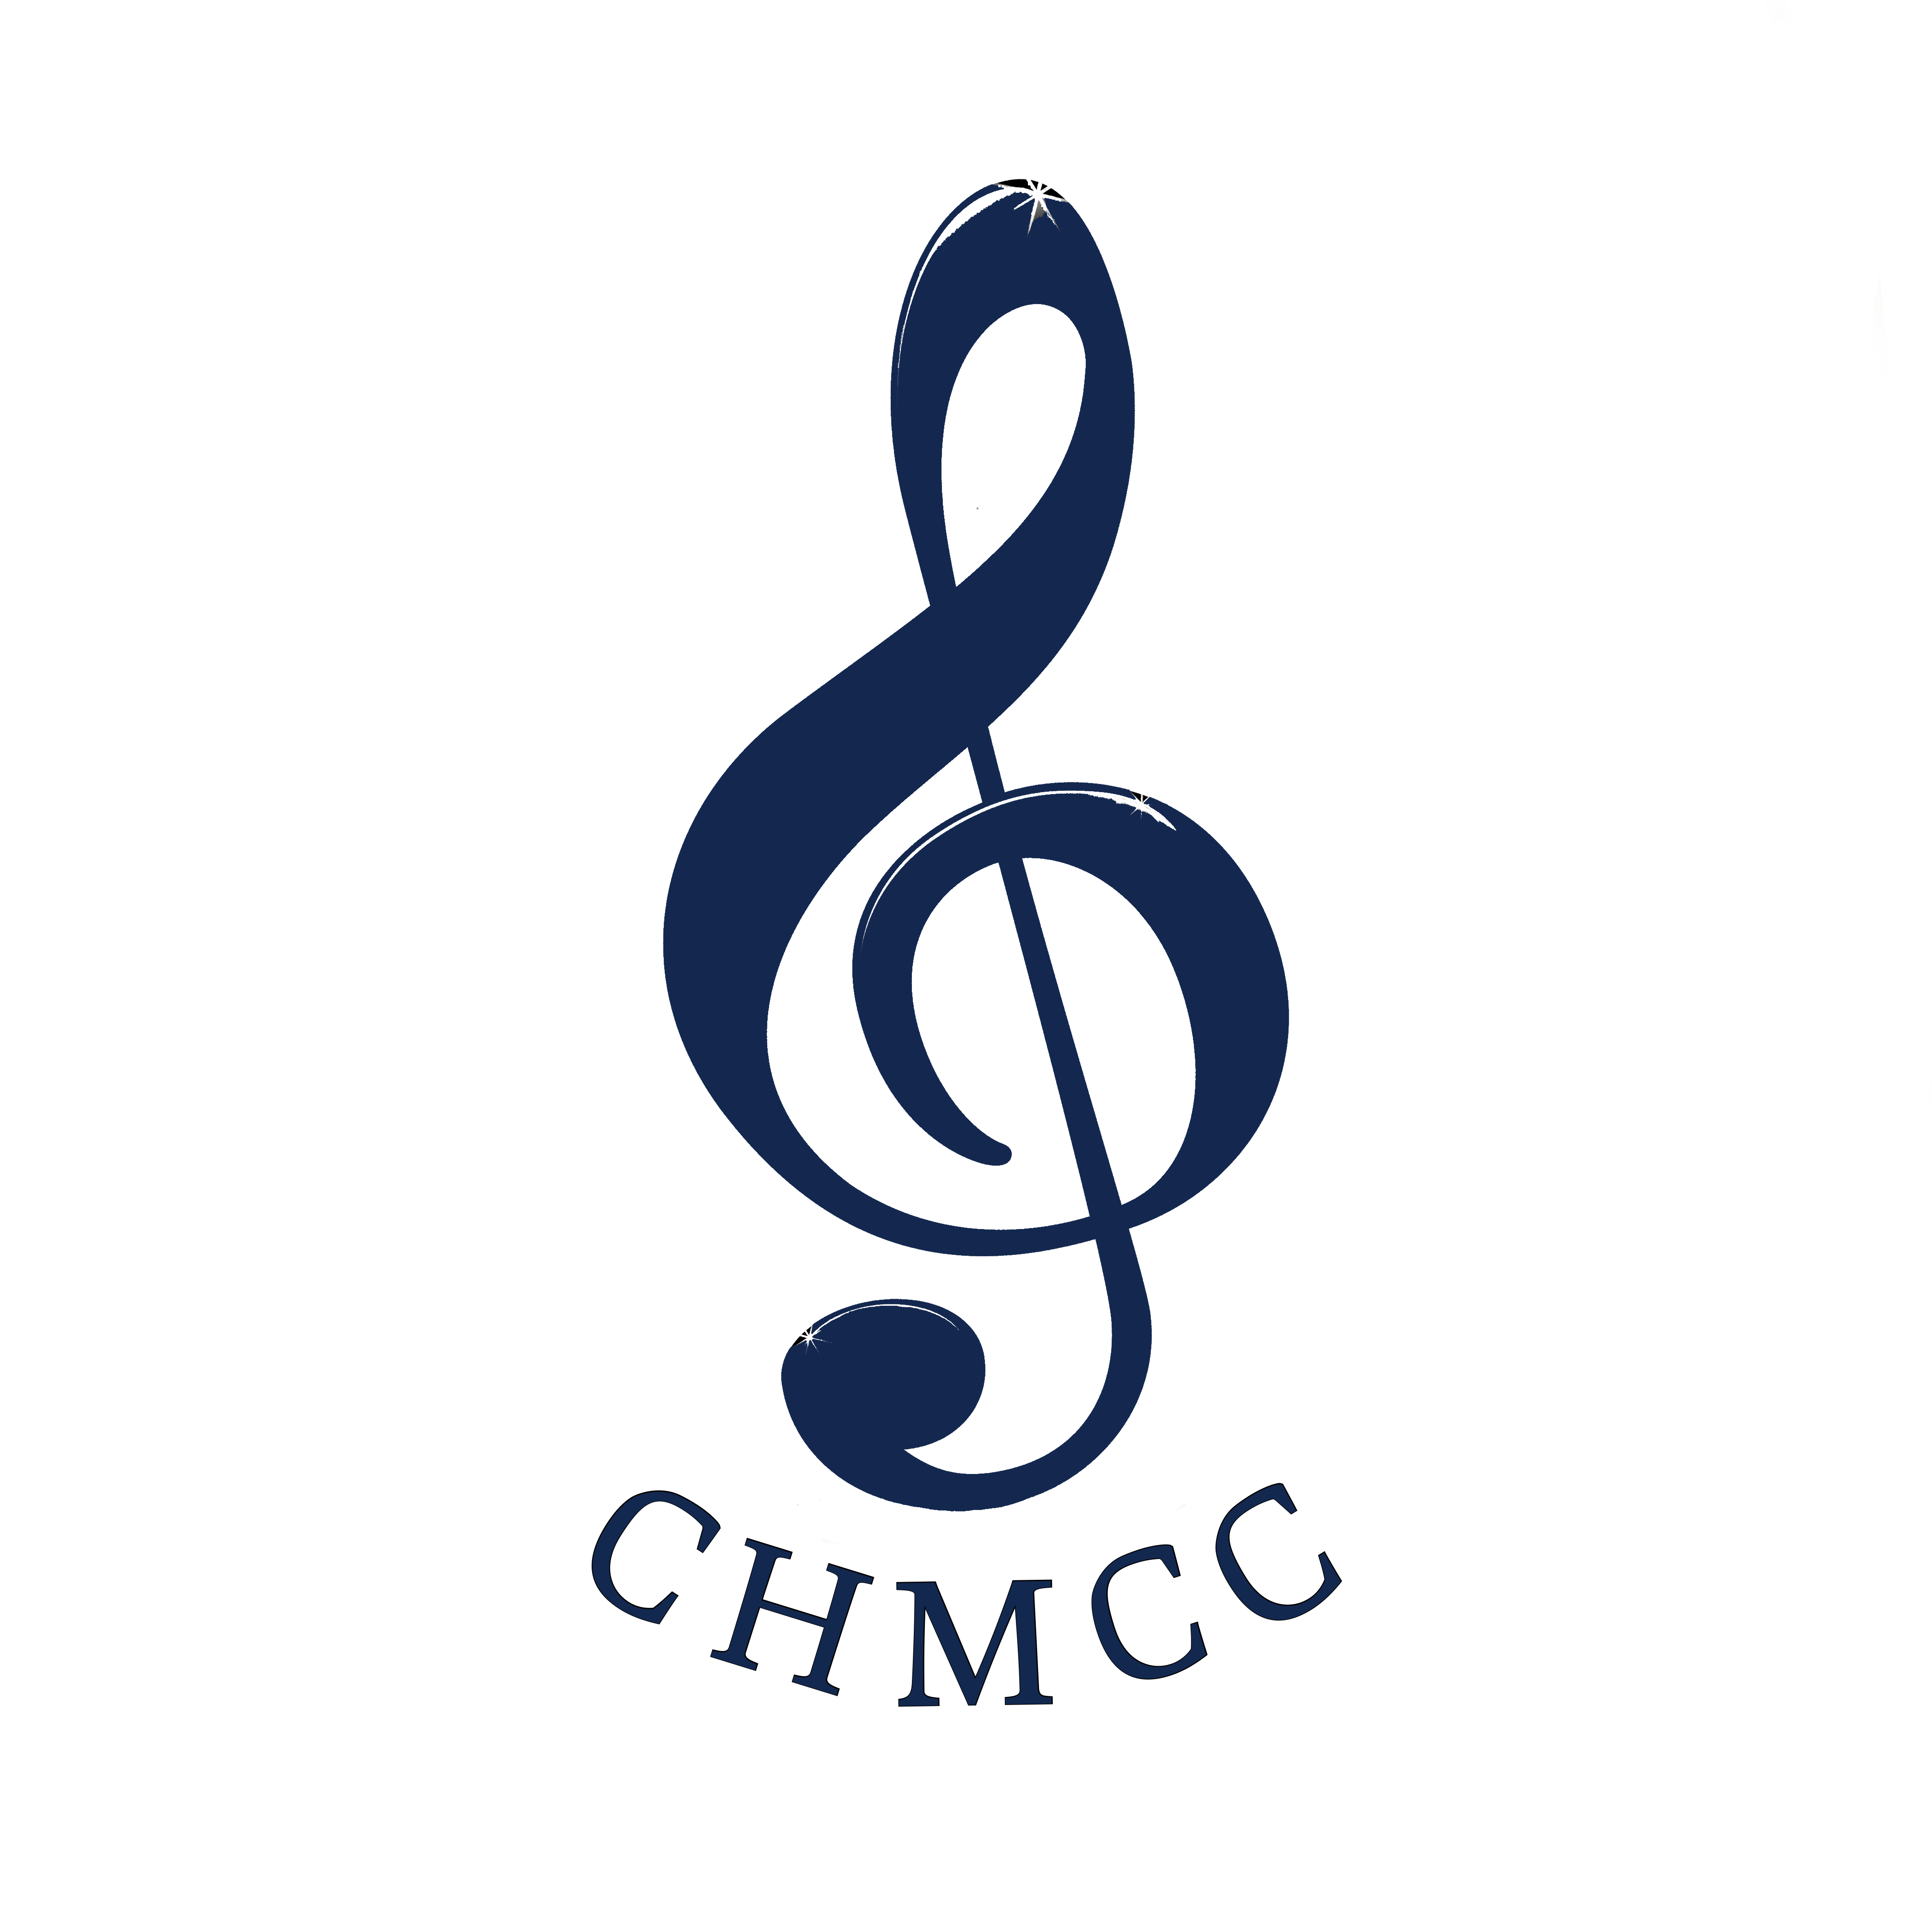
Membership Application Form Coffs Harbour Musical Comedy Co. Inc
(incorporated under the Associations Incorporation Act)

I................................................................................Guardian...............................................................
(Name of Applicant) (Name of parent/guardian if under 18)
Address..................................................................................................................................................
Email………………………………………………………………………………………………………………………………………………..
Telephone (H) ............................... (W) …………….................(Mobile)...................................................
DOB……………………….. Occupation.........................................................................................................

Hereby apply to become an Ordinary member of the above-named incorporated association. In the event of my admission as a member, I agree to be bound by the rules of the association currently in force.
Signed..............................................Guardian (if<18)................................... Date…………………………

The applicant is known to the nominator and seconder who are members of the association,
whose signatures appear below & who propose that the applicant be granted membership
of the association.
Nominator................................................................ Seconder .......................................................

PLEASE NOTE: For children participating in a production a parent must sign:
I hereby approve my son/daughter to participate in the CHMCC production of:

.........................................................................................................................................................

I accept full responsibility for the safe supervision and transport of my child to and from
all rehearsals and performances of this production. I hereby absolve all members of
the company from responsibility for injuries or illness sustained by my child, other than
where negligence can be shown. I consent to photographs being taken of my child for publicity purposes.

Name...............................................................Signed..............................................(parent/guardian)

GENERAL INFORMATION: Membership fees are for a calendar year.
Ordinary: (Includes concession and students) $10 ________Family (4) $20__________

INTERESTS: (Please tick): Acting Singing Dancing Lighting Sound Backstage Directing Graphic Design Hair/Make-up Set design Set Construction
Front of House Costumes/Sewing Publicity Other
Musician: .................................. (Please specify instrument)

Fees may be sent to: CHMCC PO Box 1466, Coffs Harbour NSW 2450 or paid by direct deposit.
Bank Details for direct deposit:
BSB: 533000 Account: 43918 Account Name: Coffs Harbour Musical Comedy Company

Approved Committee Meeting: .............................(date) Receipt No:.................... (date) ..........

